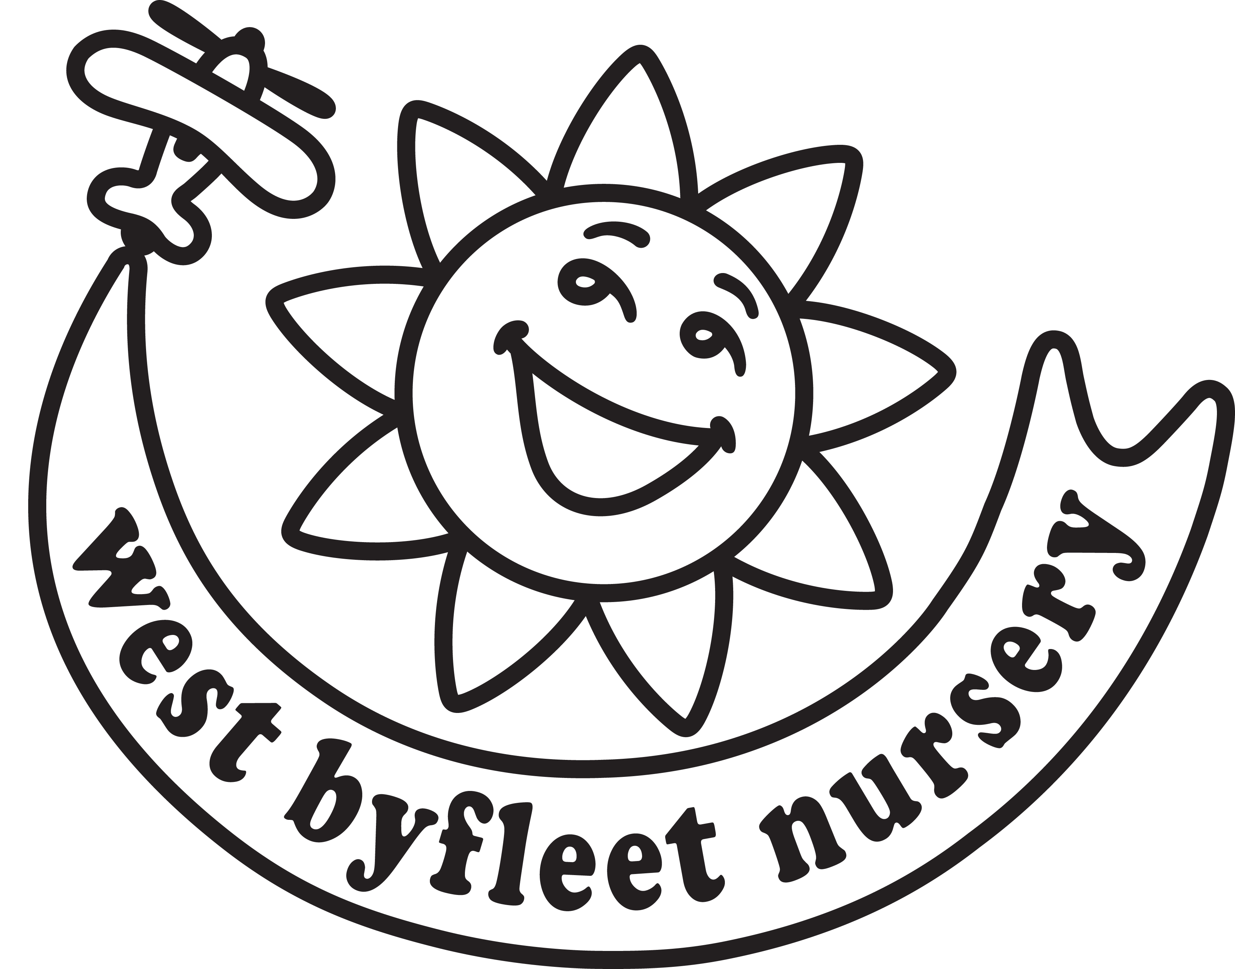Registration Form

Child’s Surname: | Date of Birth: / /
Forenames: | Gender:  Male  Female
Preferred name (If different):

Please include the full name, address, email address and telephone numbers of all those with parental responsibility for this child:
Name of Parent/Carer (including title) |  |  |  | Name of Parent/Carer (including title)
Home Address:  Postcode: |  |  |  | Home Address:  Postcode:
Home telephone:  Mobile: |  |  |  | Home telephone:  Mobile:
Email address: |  |  |  | Email address:
These email addresses will be used to confirm receipt of this form, keep you informed regarding waiting lists and offers of places.
Please indicate when you would like your child to start and which sessions you require:
Start date: September/ January /April (delete as applicable) Year: 20_ _
- All children are eligible for 15 hours universal entitlement from the term following their third birthday, places are offered for 5 three-hour sessions per week and can be taken as required, across our core hours (9.00 – 12.00 and 12.30 - 3.30) subject to availability.
- Working families of 3- and 4- year-olds may be eligible for 30 hours of funded childcare. Eligibility for this is determined by HMRC; please visit www.childcarechoices.gov.uk for full information. We offer families, with a valid eligibility code, up to 30 funded hours across our core hours (9.00 - 12.00 and 12.30 - 3.30).
- Working families of 2-year-olds may be eligible for 15 hours of funded childcare. Eligibility for this is determined by HMRC; please visit www.childcarechoices.gov.uk for full information. We offer families, with a valid eligibility code, up to 15 funded hours across our core hours (9.00 - 12.00 and 12.30 - 3.30). Please note, we only take children the term that they turn 3 years old, and we have limited availability for these sessions.
- Where a child stays on site for the lunch club (12.00 - 12.30) a fee is payable for this non-funded period.
- We also offer unfunded wrap around sessions which can be used to extend the day from 8.00am or 8.30am
to 4pm or 6pm; if required.
- Paid sessions can be taken in any combination as available. Please see our Terms and Conditions for full details.
I will be claiming 15 hours universal entitlement for my child
YES/NO
YES/NO

Working families:
I believe I will be eligible and would like to claim all or part of the 15- or 30-hours entitlement.

Number of funded hours to be claimed at this setting.

 | Early Morning |  | Morning  Session  9.00 - 12.00 |  | Lunch Club*  12.00 - 12.30 | Afternoon Session  12.30 -3.30 | End of day
 | Breakfast Club*  8.00-9.00 | Bright and Breezy* 8.30 - 9.00 |  |  |  |  | 4 O'clock pick up*  3.30 - 4.00 | 6 O'clock pick up*  3.30 - 6.00
Monday
Tuesday
Wednesday
Thursday
Friday
Charges (Sept 23) | £9.00 | £5.25 | £26.00 |  | £8.50 | £26.00 | £5.25 | £14.50
* Please note - Only our core hours can be funded sessions.
*Please note – 6pm club will not run on the last day of each term, (Xmas, Easter, and Summer)
Other than breakfast club and 6 o’clock pick up, food is not included, please provide packed lunch and snacks as appropriate.

Please tell us about any medical conditions (including long term medication), allergies, special educational needs, or disabilities your child may have:

Home Language:

Language spoken by child:

Conditions of Acceptance of Registration:

A one-off administration fee of £30 will be payable on your first invoice. This is only applicable to those families accessing additional paid sessions. Offers of places will be made early in the term immediately preceding your requested start date.

All those with parental responsibility for this child must sign below to confirm their agreement with this application unless there is a court order in place that states otherwise. A copy of this must be provided.
We/ I wish to register our/my child for a place at West Byfleet Nursery.
I have read the Nursery’s Terms and Conditions and understand and agree to abide by them.

Signed: | Signed:
Full Name: | Full Name:
Relationship to child: | Relationship to child:
Date: | Date:

Please return this form to:
Admissions,
West Byfleet Nursery Ltd, Camphill Road, West Byfleet, Surrey, KT14 6EF
We can be contacted on 01932 353288 or 07934 232581
and at westbyfleetnursery@hotmail.co.uk should you have any questions

For office use:

Date received:

January 2024

